**SAP Implementation Project**

**At**

**Government of Andhra Pradesh**

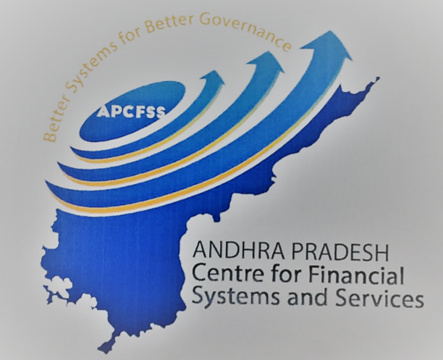

**Project CFMS**

**(Comprehensive Financial Management System)**

**Technical Design Document**

**BILL STATUS DETAILS REPORT**

Document Version : 1.1

Document Release Date : 08th, October, 201819.08.03 13:02

**Only for internal use**

Table of Content

1. Introduction 3

1.1 Purpose of this document3

1.2 Scope of this document3

2. Document Identification 3

3. DOCUMENT History 4

4. PROCESS Description 5

5. REPORTING SCOPE 5

6. FUNCTIONALITY REQUIREMENTS 5

7. TECHNICAL REQUIREMENTS - REPORT 5

7.1 WebI Basic Overview: Annexure for Bill Status Detail Report5

8 TECHNICAL REQUIREMENTS - REPORTS 6

8.1 Objects, Variable and Report Controls used.6

8.2 Bill Status Details Report Level Calculations and Formulas used.8

Appendix A -- 11

Appendix B – 11

# 

# Introduction

## Purpose of this document

The purpose of this document is to describe the Technical Design of BILL STATUS DETAILS REPORT at CFMS ( Comprehensive Finance Management System ) for Department of Finance, Govt. of Andhra Pradesh.

## Scope of this document

This document contains the technical description and design of BILL STATUS DETAILS REPORT.

# Document Identification

|  |  |  |
| --- | --- | --- |
| Document details | | |
| Project Name | Module | Business Scenario - |
| GoAP | Business Objects | Expenditure |
| Module Lead – GoAP | Module Lead – SAP/Partner | Process Owner |
|  | Manoj Dhir |  |
| BBP Number | BBP Name |  |
|  | BO Reports |  |

# DOCUMENT History

|  |  |  |  |  |
| --- | --- | --- | --- | --- |
| **Authors & Participants** | | | | |
| **Role** | | **Names** | | |
| Core Team Member | |  |  | |
| Consultant | | Nageswara Rao Adabala |  | |
| Business Process Owner / FICO Lead | |  |  | |
| Workshop Participants | |  |  | |
| **Revision History** | | | | |
| **Date** | **Document Version** | **Document Revision Description** | | **Author** |
| 5/7/2018 | 1.0 | Draft for Internal Technical review | | Nageswara Rao |
| 8/10/2018 | 1.1 | Bill DDO Description And Input controls changed | | Pradeep Kumar |
| **Reviewed and Approved By** | | | | |
| **Name** | **Title** | **Date** | | **Approved** |
|  |  |  | |  |

# PROCESS Description

**Business Process: Bill Status Details Report**

This report gives information of State wide Overall Bill Status, Gross, Net amount figures,and also givesactions for processing Bills at various stages.

we can see the Bill Type, Bill Sub Type, Total Bills, cancelled, Actual Bills, Under Preparation, Under Scrutiny, Approved, Gross Paid Amount, Net Amount Paid, Gross To Be Paid Amount, Net Amount To Be Paid, Bill Created Date.After that Bill Status HOA,Bill number,Bill Type...etc complete bill status details are explained here.

# REPORTING SCOPE

This Report displays Bill Status HOA, Bill Number, Bill Type, Bill Status, Total Beneficiaries, Gross Paid Amount, Net Paid Amount, Gross To Be Paid Amount, Net To Be Paid Amount for the selected district wise bill.

# FUNCTIONALITY REQUIREMENTS

| DESCRIPTION | CATEGORY |
| --- | --- |
| Report Name | Bill Status Detail Report |
| Objective/Purpose/Business Use | Reporting and Analysis |
| End Users/Beneficiary | Management |
| Frequency | Refresh on Demand |
| Reporting Tools | WebI |
| Export Format- Excel/Pdf/ | Excel/PDF |
| Scheduling Required: Y/N | NA |

# TECHNICAL REQUIREMENTS - REPORT

## WebI Basic Overview: Annexure for Bill Status Detail Report

|  |  |
| --- | --- |
| DESCRIPTION | CATEGORY |
| Filter | NA |
| Dimension (Fields) | Bill Number,Bill Status,Bill Sub Type,Bill Type,HOA |
| Measure(Value) | Gross To be Paid Amount, Beneficiaries Unpaid, Total Gross Amount, Total Beneficiaries, Net Paid Amount, Net To be Paid Amount, Beneficiaries Paid,  Gross Paid Amount |
| Drill Down Hierarchies | NA |
| Sorting | NA |
| Conditional Formatting | Applied on number columns to attain Indian numbering format. |
| Breaks | Can be applied |
| Sections | NA |

# TECHNICAL REQUIREMENTS - REPORTS

## Objects, Variable and Report Controls used.

**List of HANA-Objects and View Types.**

|  |  |  |  |
| --- | --- | --- | --- |
| **HANA VIEW NAME** | **OBJECTS** | **OBJECTTYPE** | **VIEWTYPE** |
| **CV_BILL_TYPE_STATUS_DET** | Bill Number | **String** | **Dimension** |
| Bill Status | **String** | **Dimension** |
| Bill Sub Type | **String** | **Dimension** |
| HOA | **String** | **Dimension** |
| Bill Type | **String** | **Dimension** |
| Gross To be Paid Amount | **Numeric** | **Measure** |
| Beneficiaries Unpaid | **Numeric** | **Measure** |
| Total Gross Amount | **Numeric** | **Measure** |
| Total Beneficiaries | **Numeric** | **Measure** |
| Net Paid Amount | **Numeric** | **Measure** |
| Net To be Paid Amount | **Numeric** | **Measure** |
| Beneficiaries Paid | **Numeric** | **Measure** |
| Gross Paid Amount | **Numeric** | **Measure** |

**List of Variables, Formulas used with Variables and Qualification Types.**

|  |  |  |  |
| --- | --- | --- | --- |
| **VAR-NAME** | **FORMULA** | **VAR-TYPE** | **QUALIFICATION** |
| CurrencyFlag | =If([CurrencyScaling]="Crore") Then 1 Else If([CurrencyScaling]="Lakh") Then 2 Else 0 | Number | Dimension |
| CurrencyScaling | ="Rupees" | TEXT | Dimension |
| From Date | =UserResponse([Query 2];"psHana Variable IP_FROM_DATE") | TEXT | Dimension |
| IP_DDO | =UserResponse([Query 2];"psHana Variable IP_DDO") | TEXT | Dimension |
| IP_District | =UserResponse([Query 2];"psHana Variable IP_DISTRICT") | TEXT | Dimension |
| IP_Treasury | =UserResponse([Query 2];"psHana Variable IP_TREASURY") | TEXT | Dimension |
| To Date | =UserResponse([Query 2];"psHana Variable IP_TO_DATE") | TEXT | Dimension |

## Bill Status Details Report Level Calculations and Formulas used.

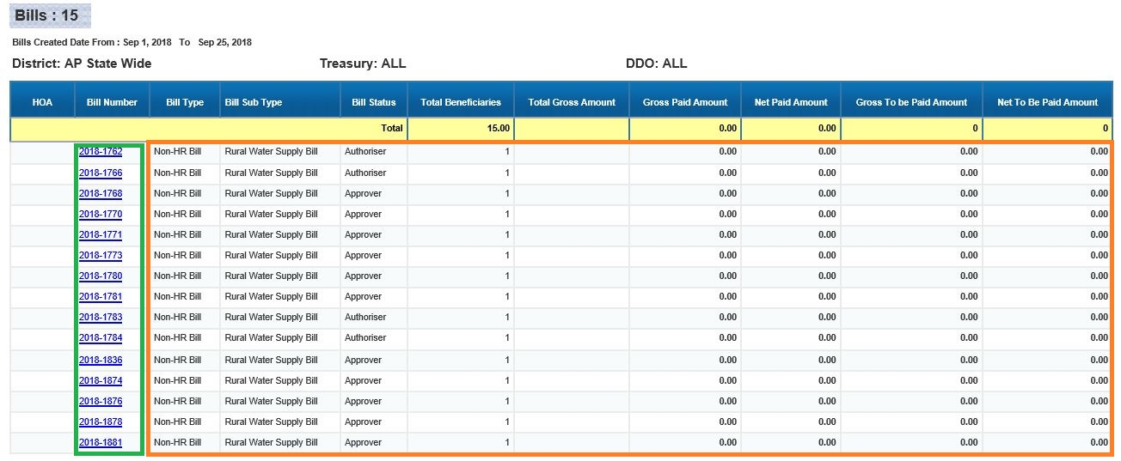

This Report displays **Bill Number, Bill type, Bill sub type,** Bill status and Total Benificeries for AP State-Wide till date with Gross paid amount, Net paid amount, Gross to be paid amount, Net to be paid amount for Selection date and yearare under the header highlighted in ***Yellow***.

The Rows within the ***Orange*** Box are derived from the Col-Formulas, and The Rows within the ***Green*** Box are derived from Document Prompts with Linking of the **Bill Hoa Detail report**, which would Populate the Bill number.Clicking on hyperlink the report will be redirected to Public Domain Site.

In this Fiori Report, we can see the detailed view of particular Bill Number.

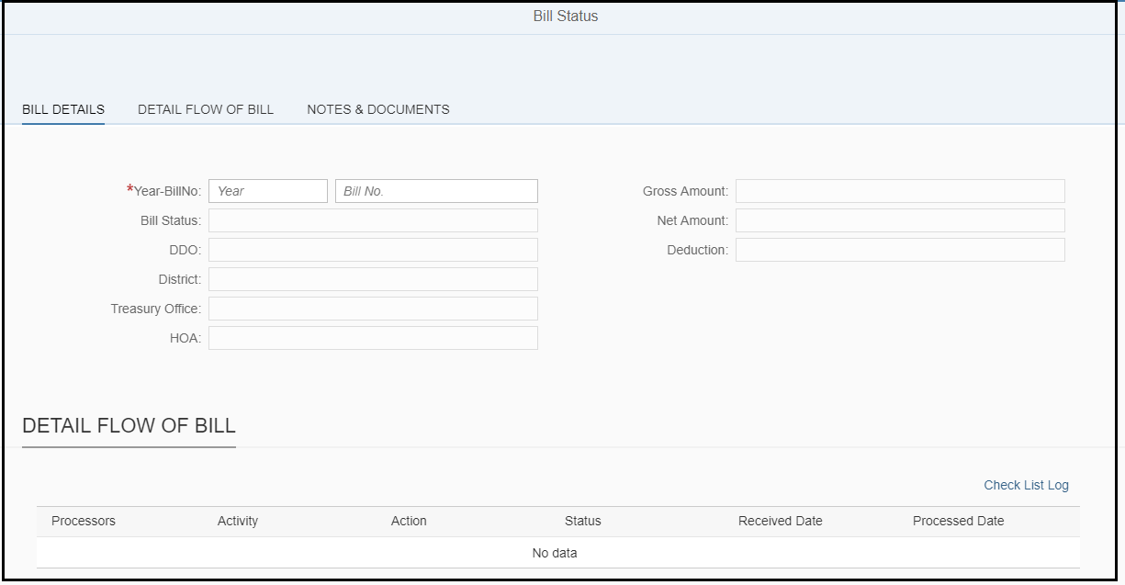

**List of Formulas used in Report Layer.**

|  |  |  |  |  |
| --- | --- | --- | --- | --- |
| **Column Names** | **Columns Description** | **Columns Names Formula** | **Col-Formula** | **AP State-wide** |
| HOA | HOA corresponding to the bill number | =Char(10)+NameOf([HOA]) | =[HOA] | Total |
| Bill Number | Bill Number | =Char(10)+NameOf([Bill Number]) | ="<a href=\"https://prdcfms.apcfss.in:44300/sap/bc/ui5_ui5/sap/zexp_billstatus/index.html?sap-client=''&billNum="+(""+[Bill Number])+"\" title=\"\" target=\"_blank\" nav=\"web\">"+[Bill Number]+"</a>" | Total |
| Bill Type | Type of Bill | =Char(10)+NameOf([Bill Type]) | =[Bill Type] | Total |
| Bill Sub Type | Sub categorised of a bill | =Char(10)+NameOf([Bill Sub Type]) | =[Bill Sub Type] | Total |
| Bill Status | Status of a bill | =Char(10)+NameOf([Bill Status]) | =[Bill Status] | Total |
| Total Beneficiaries | Total no of persons benfited | =Char(10)+NameOf([Total Beneficiaries]) | =[Total Beneficiaries] | =[Total Beneficiaries] |
| Total Gross Amount | Total Gross amount to be paid | =Char(10)+NameOf([Total Gross Amount]) | =If ([CurrencyFlag] = 1) Then ([Total Gross Amount])/10000000 Else If([CurrencyFlag] = 2) Then ([Total Gross Amount])/100000 Else ([Total Gross Amount]) | =If ([CurrencyFlag] = 1) Then ([Total Gross Amount])/10000000 Else If([CurrencyFlag] = 2) Then ([Total Gross Amount])/100000 Else ([Total Gross Amount]) |
| Gross Paid Amount | Gross amount paid | =Char(10)+NameOf([Gross Paid Amount]) | =If ([CurrencyFlag] = 1) Then ([Gross Paid Amount])/10000000 Else If([CurrencyFlag] = 2) Then ([Gross Paid Amount])/100000 Else ([Gross Paid Amount]) | =If ([CurrencyFlag] = 1) Then ([Gross Paid Amount])/10000000 Else If([CurrencyFlag] = 2) Then ([Gross Paid Amount])/100000 Else ([Gross Paid Amount]) |
| Net Paid Amount | Net amount paid | =Char(10)+"Net Paid Amount" | =If ([CurrencyFlag] = 1) Then ([Net Paid Amount])/10000000 Else If([CurrencyFlag] = 2) Then ([Net Paid Amount])/100000 Else ([Net Paid Amount]) | =If ([CurrencyFlag] = 1) Then ([Net Paid Amount])/10000000 Else If([CurrencyFlag] = 2) Then ([Net Paid Amount])/100000 Else ([Net Paid Amount]) |
| Gross To be Paid Amount | Gross amount to be paid | =Char(10)+NameOf([Gross To be Paid Amount]) | =If ([CurrencyFlag] = 1) Then ([Gross To be Paid Amount])/10000000 Else If([CurrencyFlag] = 2) Then ([Gross To be Paid Amount])/100000 Else ([Gross To be Paid  Amount]) | =If ([CurrencyFlag] = 1) Then ([Gross To be Paid Amount])/10000000 Else If([CurrencyFlag] = 2) Then ([Gross To be Paid Amount])/100000 Else ([Gross To be Paid  Amount]) |
| Net To Be Paid Amount | Net amount to be paid | =Char(10)+"Net To Be Paid Amount" | =If ([CurrencyFlag] = 1) Then ([Net To be Paid Amount])/10000000 Else If([CurrencyFlag] = 2) Then ([Net To be Paid Amount])/100000 Else ([Net To be Paid Amount]) | =If ([CurrencyFlag] = 1) Then ([Net To be Paid Amount])/10000000 Else If([CurrencyFlag] = 2) Then ([Net To be Paid Amount])/100000 Else ([Net To be Paid Amount]) |

**Bill Status Detail Report Level User Prompts & Input Controls used.**

1. There is **thirteen** User Prompt used in the Bill Status Detail Report.
2. From Date
3. To Date
4. District(optional)
5. Treasury(optional)
6. DDO(optional)
7. Bill Type(optional)
8. Bill Sub Type(optional)
9. Bill Status(optional)
10. Head Of Account(optional)
11. Major Head(optional)
12. Group Sub Head(optional)
13. Sub Head(optional)
14. Department – HOA(optional)
15. There is **One** Input Control used in the Bill Status Detail Report.
16. Currency Scaling

Appendix A–

Appendix B –